Lab 22-1 | Editing and Validating Object Definitions
Objective: To practice using Siebel Tools for editing and validating object definitions. |  |  10-15 minutes

Instructions:
You will practice modifying object definitions in Siebel Tools in this lab. You will verify your changes using Tools’ Validation tool.

- You will start this lab by changing the value of properties in both the Object List Editor (OBLE) and the Properties window. You will change the Visibility Applet and Comments properties for Asset Mgmt – Assets View. Which properties change is not important, but in this and the next steps you will see how Siebel Tools tracks changes to objects and projects, and how you can validate object definitions.
- Select View :: Asset Mgmt – Assets View.
- Right-click and select Lock Object.
- In the OBLE, tab over to the Visibility Applet property column and delete the field contents so that it is blank (or null). Be careful not to click the drilldown to the Asset Mgmt – Asset List Applet. Step off the record to commit your change.
- Click the Properties tab to the left side of the OE. (If it is not there, select View > Windows > Properties Window, then right-click on the Properties window display bar and select Auto- Hide.)
- In the Properties window, click the Comments property column of the Asset Mgmt – Assets View record and enter Deleted visibility applet. Step off the record to commit your change.

- You will now observe that some properties have picklists and some do not.
- Select View :: Asset Mgmt – Assets View.
- Double click the column header of the Name property to freeze the Name column in place. Scroll right and find the Thread Field property. Type in “Asset Tag” rather than using the dropdown list. Tab out of the field. What happens?

- Click Close.

- Each object definition has a property called Inactive. If Inactive is set, the object definition will not be referenced by Siebel applications. You will now explore this property.
- Make sure View :: Asset Mgmt – Assets View is selected.
- Click the Inactive column in the OBLE (this will toggle the setting of a TRUE/FALSE value). Aside from the checkmark, what visual indication appears?

- Look in the Properties window and verify that the Inactive property is set to TRUE; if not, set it to TRUE.
- Reset the Inactive property to FALSE and tab out of the column.

- Next, you will practice using the Validate option to verify your changes.
  - With View :: Asset Mgmt – Assets View selected in the OBLE, right-click and select Validate.
  - Click Start to validate the Asset Mgmt – Assets View object definition. Wait a few moments for the validation to complete.
    - Select the errors listed and inspect the details listed in the Details box. Which rule number was violated?

    - Click Save As to save the details in a log file.
    - Click Save.

  - Click Options to examine the rules that are checked during validation.
    - Click the Object column heading to sort the rules list by object type.
    - Which rule numbers are specific to View objects?

    - Which two rules apply to all objects?

    - Select Rule 7.
    - Click Ignore to deactivate the rule. If necessary, scroll right to find the Enforce column. Notice that its value is now No.
    - Click OK.

  - Click Start to rerun your validation. Were any errors listed in the errors list? Why or why not?

  - Click Load to examine the original validation error message. Click Open to view the former log file.
  - Click Options to reactivate the screen rule.
    - Select Rule 7.
    - Click Enforce to reactivate the rule. Notice the Enforce column value changes to Yes.
    - Click OK.
  - Click Cancel to close the dialog box.

Note: Validating your work frequently is a recommended practice.
Solutions Lab 22-1 Editing and Validating Object Definitions

2.b. The value you entered disappeared and a pick applet showing a list of available fields appears. Because Tag Asset isn’t a value that appears in the drop-down list, and this field doesn’t accept any such values, Siebel Tools disallows this entry.

3.b. The color of the text for this record changes to red.

4.b.i. Rule number 7

4.c.ii. Rule numbers 3, 5, 6, 7, 10, 11, 97, 118

4.c.iii. Rule numbers 1 and 61

4.d. No errors were detected, because the relevant error check has been deactivated.

Lab 22-2 | Exporting and Importing Object Definitions
Objective: To learn the process of exporting and importing object definitions |  |  10-15 minutes

Instructions:
Exported object definitions can be used to compare or overwrite the existing object definitions when you are not sure whether all the modifications done to them are correct or not. In this lab, we will see how to export/import the object definitions and also comparing them against each other to get a clear picture of the differences.

- If necessary, double-click on the Siebel Tools shortcut on the desktop. Login as SADMIN/SADMIN connecting to Sample database.
- Exported object definitions are stored in the files with extension .sif. We will try to export the Service Request business component definition in this step.
- Select Business Component :: Service Request
- Select Tools > Add to Archive…
- Once the object definition is loaded, specify the path where you want to save the file. Let the file be saved at location D:\siffiles\servicerequest.sif
- Right-click the servicerequest.sif file and select Open.
- Select Select the program from a list and click OK
- In the Open With dialog box, select Notepad. Click OK.
- Observe the structure of the file. Do not make any changes. What does this file appear to contain?

- When you are finished, close the WordPad application.

3. Project definitions can also be exported as a whole
- Select Project :: Service.
- Select Tools > Add to Archive…
- Once the object definition is loaded, specify the path where you want to save the file.

4. Modify the Service Request BC
- Select Business Component :: Service Request.
- Lock the object.
- See for the Search Specification property. What is its value?

- Remove the Search Specification property value and save the record by stepping off it.
- Now tab to the Comments property. Add your comment appending the deleted search specification value.
- Select Business Component :: Service Request | Field :: Abstract
- Set the Inactive property for this field.

- Now, you will see how to compare the existing Service Request definition and the original one.
- Select Business Component :: Service Request
- Right click and select Compare Objects > Archive File

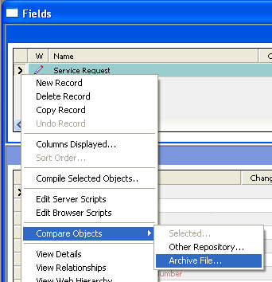

- Select the D:\siffiles\servicerequest.sif file
- In the left-hand Compare Objects window, expand Service. Notice how the right-hand window mirrors this action.
- Examine the folder icon next to each node in the tree. Blue indicates no difference between the two definitions of an object or type. Pink indicates a difference. What object type is marked with pink in the tree?

- Expand the Business Component type.
- What difference is listed in the properties applet at the lower part of the dialog box for the Service Request business component?

- Expand Service Request. Scroll through the child objects and look for the object that indicates the difference. What is the object noticed?

- Expand the Field and see that Abstract is in pink. See the properties window at the lower part of the dialog box to find the differences.
- Click close

- Now you will import the Service Request archive file to restore the original definition of the Service Request
- Select Business Component :: Service Request
- Select Tools > Import from Archive…Select the D:\siffiles\servicerequest.sif from the path and click Open.
- Import wizard opens up and lists the object definitions in the archived file. What is the default option it provides for importing?

- In order to restore the object definition to its normal state, we select the Overwrite the object definition in the repository option. However, here Keep the default selection, Merge the object definition.., and click Next.
- Now the Conflicts resolution dialog box opens up and provides you with the options for selecting the desired action. Select File to keep the definition as in the archived file. Select the Repository to keep the definition as in the repository. Select the Merge to merge both.

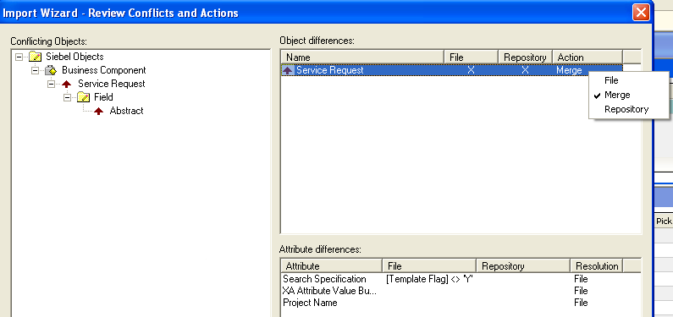

- Select File for all the differences listed and click Next.
- Once the object definition is imported, click Finish.

- Leave Siebel Tools open for the next lab.
Solutions Lab 22-2 Exporting and Importing Object Definitions

2.g. XML data with object definition

4.c. [Template Flag] <> 'Y'

5.e. Business Component

5.g. Search Specification is Blank in the Siebel Repository and it contains a value [Template Flag] <> 'Y' in the archive file

5.h. Field

6.c. Merge the object definition from the archive file with the definition in the repository

